Project Title:
Heart Disease Prediction System

Project Id: AIML-18

Student Name: SARTHAK SINGH CHAUHAN
University Roll number: 2028842
Section: U

Student Name: HEMANG SETHI
University Roll number: 2028726
Section: U

Student Name: HEMANT SINGH
University Roll number: 2028727
Section: U

TABLE OF CONTENTS
- Problem Description 3
  - Dataset Description 3
  - Flow diagram 3
- Modules for Project Implementation…………………..…………………………4
  - Modules Used 4
  - Platform Used 5
- Machine Learning model/ Searching Technique used 6
- Evaluation metrics used 7
- Results 8
- Conclusion and Future Scope 9
- References 10

- Problem Description
Heart disease remains one of the primary causes of mortality worldwide. Early detection of cardiovascular risk can significantly reduce complications and improve patient outcomes. This project proposes a Heart Disease Prediction System that leverages machine learning techniques to analyze patient data and predict the likelihood of heart disease.
The system uses clinical features such as age, gender, blood pressure, cholesterol levels, chest pain type, fasting blood sugar, ECG results, and other relevant indicators. Raw healthcare data often contains missing values, noise, and inconsistencies; therefore, a robust data preprocessing pipeline is required to ensure data quality.
After cleaning, feature scaling is applied to bring all variables to a comparable range, which is essential for distance-based algorithms such as KNN. Feature selection techniques are employed to retain only the most informative attributes, reducing overfitting and improving computational efficiency.
The system employs Logistic Regression for probabilistic prediction and K-Nearest Neighbors for instance-based classification. The final model assists healthcare professionals in identifying high-risk patients and recommending preventive measures such as medication, diet control, and lifestyle changes.

  - Dataset Description– Spam Email Detection System
The dataset used for the Heart Disease Prediction System is sourced from Kaggle, a well-known platform for publicly available machine learning datasets. To enhance the performance and reliability of the prediction model, the dataset size was expanded and refined with the assistance of ChatGPT by incorporating additional synthetic and balanced data samples.
This dataset contains various medical and demographic attributes of patients that are commonly associated with heart disease risk. Key features include age, name (for identification purposes), sex, cholesterol level, and other relevant clinical parameters such as blood pressure, heart rate, and lifestyle indicators. These attributes collectively help in analyzing patterns and predicting the likelihood of heart disease in individuals.
The dataset has been preprocessed to handle missing values, normalize data ranges, and ensure consistency across all records. The augmentation process also helps in reducing bias and improving the generalization capability of the prediction system.

1.2 Flow Diagram

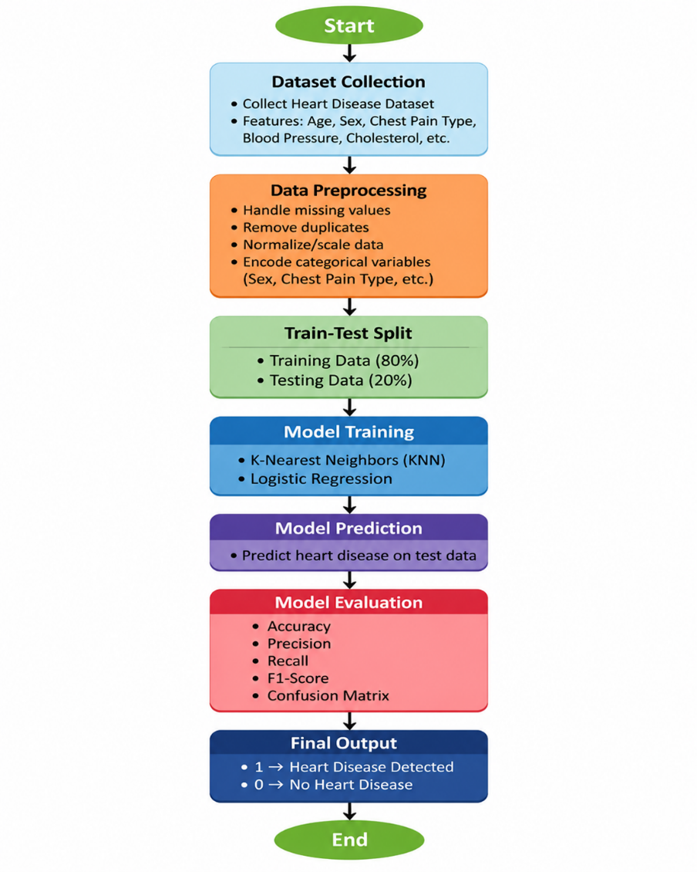

2. Modules for Project Implementation

2.1 Modules Used(mention all the inbuilt/ custom modules used and the purpose)

🔹 1. Inbuilt / Standard & External Modules
1. NumPy
Purpose:Numerical.computations.and.array.operations
Functions Used:
- array() → Create arrays for data handling
- zeros(), ones() → Initialize matrices
- reshape() → Change shape of data

2. Pandas
Purpose:Data.manipulation.and.dataset.handling
Functions Used:
- read_csv() → Load dataset
- head() → View first few rows
- info() → Dataset summary
- drop() → Remove unnecessary columns
- apply() → Apply preprocessing functions

3. re (Regular Expressions)
Purpose:Text.cleaning.and.preprocessing
Functions Used:
- sub() → Remove punctuation, special characters
- findall() → Extract words or patterns

4. NLTK (Natural Language Toolkit)
Purpose:Text.preprocessing
Functions Used:
- stopwords.words() → Remove common words
- word_tokenize() → Split text into words
- PorterStemmer() → Convert words to root form

5. scikit-learn
Purpose: Machine learning models and evaluation
a) Feature Extraction
- CountVectorizer() → Convert text to Bag of Words
- TfidfVectorizer() → Convert text to TF-IDF features
b) Model Training
- LinearRegression() → Classification model
- KNN() → K-Nearest Neighbors
c) Model Evaluation
• train_test_split() → Split dataset into training and testing sets
• confusion_matrix() → Evaluate predictions by comparing actual vs predicted values
• accuracy_score() → Calculate overall accuracy of the model
• precision_score() → Measure how many predicted spam emails are actually spam (reduces false positives)
• recall_score() → Measure how many actual spam emails are correctly identified (reduces false negatives)
• f1_score() → Harmonic mean of precision and recall, gives balanced performance measure

6. Matplotlib / Seaborn
Purpose:DATA.VISUALIZATION

🔹 2. Custom Modules / Functions
These are user-defined functions created specifically for this project:
1. Text Preprocessing Function
Purpose:Clean.and.prepare.raw.email.text
Example Functions:
- clean_text(text)
  - Removes punctuation and special characters
  - Converts text to lowercase
  - Removes stopwords

2. Feature Extraction Function
Purpose:Convert.processed.text.into.numeric.form
Example:
- vectorize_text(data)
  - Applies TF-IDF or Bag of Words

3. Model Training Function
Purpose:Train.machine.learning.models
Example:
- train_model(X_train, y_train)
  - Fits Logistic Regression / SVM

4. Prediction Function
Purpose:Predict.whether.email.is.spam.or.not
Example:
- predict_email(model, input_text)

5. Evaluation Function
Purpose:Measure.modelperformance
Example:
- evaluate_model(y_test, y_pred)
  - Generates confusion matrix and accuracy

2.2 Platform Used: (mention all the platforms with the reason of using it)
  - Visual Studio Code: For code writing, testing, and debugging.
VS Code is equipped with multiple extensions, debugger which enhance the development experience.
  - Jupyter: Provides an interactive environment for writing and testing code step-by-step . Easy visualization of outputs like graphs and confusion matrix .Useful for data preprocessing, model training, and debugging

- Machine Learning Model/ Searching Technique Used(Describe each ML model/ searching technique used)

The Spam Email Detection System uses multiple supervised machine learning models to classify emails as spam or ham based on extracted text features.

🔹 1. K-Nearest Neighbors (KNN)
Description:
K-Nearest Neighbors is a non-parametric algorithm that classifies data based on similarity.
How it Works:
- Finds the ‘K’ nearest data points (neighbors)
- Assigns class based on majority voting
Why Used:
- Simple and easy to understand
- No training phase (lazy learner)
- Useful for pattern-based classification
Limitation:
- Slow for large datasets
- Performance depends on value of K and distance metric

🔹 2. Linear Regression
Description:
- Predicts a continuous value by modeling the relationship between variables as a straight line.
Working:
. It works by finding the best-fit straight line that minimizes the difference between predicted and actual values.

4. Evaluation metrics used (Describe each evaluation metric used along with formulae)

To evaluate the performance of the Spam Email Detection System, several metrics are used based on the confusion matrix (TP, TN, FP, FN).

🔹 1. Accuracy
Description:
Measures the overall correctness of the model.
$$Accuracy=\frac{TP+TN}{TP+TN+FP+FN}$$
Where:
- TP = True Positives
- TN = True Negatives
- FP = False Positives
- FN = False Negatives

🔹 2. Precision
Description:
Out of all emails predicted as spam, how many are actually spam.
$$Precision=\frac{TP}{TP+FP}$$

🔹 3. Recall (Sensitivity)
Description:
Out of all actual spam emails, how many are correctly detected.
$$Recall=\frac{TP}{TP+FN}$$

🔹 4. F1 Score
Description:
Harmonic mean of Precision and Recall. It balances both metrics.
$$F1=2⋅\frac{Precision⋅Recall}{Precision+Recall}$$

🔹 5. Confusion Matrix
Description:
A table used to visualize model performance by comparing actual and predicted values.
 | Predicted Spam | Predicted Ham
Actual Spam | TP | FN
Actual Ham | FP | TN

5. Results :-

6. Conclusion and Future Scope:
The heart disease prediction system successfully utilizes patient data such as age, cholesterol levels, blood pressure, and other relevant health factors to assess the risk of heart disease. By applying machine learning algorithms like KNN and Linear Regression, the system is able to analyze patterns within the dataset and generate accurate predictions. This approach improves the efficiency and reliability of diagnosis compared to traditional methods.
Overall, the system can assist healthcare professionals in making informed decisions, enable early detection of potential heart conditions, and support preventive measures. With further improvements and larger datasets, the model’s accuracy and performance can be enhanced, making it a valuable tool in the field of healthcare analytics.

🔹 Future Scope
The project can be further enhanced in the following ways:
The heart disease prediction system has significant potential for future improvements and expansion. The model can be enhanced by incorporating larger and more diverse datasets, which would improve its accuracy and generalization across different populations. Advanced machine learning techniques such as deep learning and ensemble methods can also be applied to achieve better prediction performance compared to basic algorithms like KNN and Linear Regression.
In addition, the system can be integrated with real-time health monitoring devices such as wearable sensors to continuously track vital parameters like heart rate, blood pressure, and activity levels. This would enable real-time prediction and early warning alerts for patients. The development of a user-friendly mobile or web application can further increase accessibility for both patients and healthcare professionals.

